Sunday Readings of Advent, Yr B, 2020-2021

First Sunday of Advent
Mark 13:33-37
³³ “Beware, keep alert; for you do not know when the time will come.
³⁴ It is like a man going on a journey, when he leaves home and puts his slaves in charge, each with his work, and commands the doorkeeper to be on the watch.
³⁵ Therefore, keep awake-- for you do not know when the master of the house will come, in the evening, or at midnight, or at cockcrow, or at dawn,
³⁶ or else he may find you asleep when he comes suddenly.
³⁷ And what I say to you I say to all: Keep awake.”
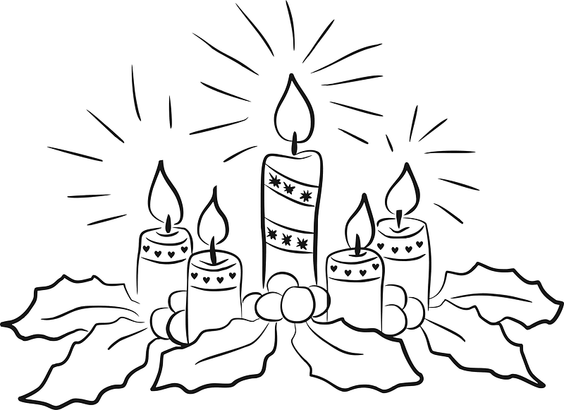
Second Sunday of Advent
Mark 1:1-8
¹ The beginning of the good news of Jesus Christ, the Son of God.
² As it is written in the prophet Isaiah,
“See, I am sending my messenger ahead of you, who will prepare your way;
³ the voice of one crying out in the wilderness
‘Prepare the way of the Lord, make his paths straight,’”
⁴ John the baptizer appeared in the wilderness, proclaiming a baptism of repentance for the forgiveness of sins.
⁵ And people from the whole Judean countryside and all the people of Jerusalem were going out to him, and were baptized by him in the river Jordan, confessing their sins.
⁶ Now John was clothed with camel's hair, with a leather belt around his waist, and he ate locusts and wild honey.
⁷ He proclaimed,
“The one who is more powerful than I is coming after me; I am not worthy to stoop down and untie the thong of his sandals.
⁸ I have baptized you with water; but he will baptize you with the Holy Spirit.”

Third Sunday of Advent
John 1:6-8, 19-28
⁶ There was a man sent from God, whose name was John.
⁷ He came as a witness to testify to the light, so that all might believe through him.
⁸ He himself was not the light, but he came to testify to the light.
¹⁹ This is the testimony given by John when the Jews sent priests and Levites from Jerusalem to ask him, “Who are you?”
²⁰ He confessed and did not deny it, but confessed, “I am not the Messiah.”
²¹ And they asked him, “What then? Are you Elijah?” He said, “I am not.”
“Are you the prophet?” He answered, “No.”
²² Then they said to him, “Who are you? Let us have an answer for those who sent us. What do you say about yourself?”
²³ He said, “I am the voice of one crying out in the wilderness, ‘Make straight the way of the Lord,’” as the prophet Isaiah said.
²⁴ Now they had been sent from the Pharisees.
²⁵ They asked him,
“Why then are you baptizing if you are neither the Messiah, nor Elijah, nor the prophet?”
²⁶ John answered them,
“I baptize with water. Among you stands one whom you do not know,
²⁷ the one who is coming after me; I am not worthy to untie the thong of his sandal.”
²⁸ This took place in Bethany across the Jordan where John was baptizing.

Fourth Sunday of Advent
Luke 1:26-38
²⁶ In the sixth month the angel Gabriel was sent by God to a town in Galilee called Nazareth, ²⁷ to a virgin engaged to a man whose name was Joseph, of the house of David. The virgin's name was Mary.
²⁸ And he came to her and said,
“Greetings, favored one! The Lord is with you.”
²⁹ But she was much perplexed by his words and pondered what sort of greeting this might be. ³⁰ The angel said to her,
“Do not be afraid, Mary, for you have found favor with God. ³¹ And now, you will conceive in your womb and bear a son, and you will name him Jesus. ³² He will be great, and will be called the Son of the Most High, and the Lord God will give to him the throne of his ancestor David. ³³ He will reign over the house of Jacob forever, and of his kingdom there will be no end.”
³⁴ Mary said to the angel,
“How can this be, since I am a virgin?”
³⁵ The angel said to her,
“The Holy Spirit will come upon you, and the power of the Most High will overshadow you; therefore the child to be born will be holy; he will be called Son of God. ³⁶ And now, your relative Elizabeth in her old age has also conceived a son; and this is the sixth month for her who was said to be barren.
³⁷ For nothing will be impossible with God.”
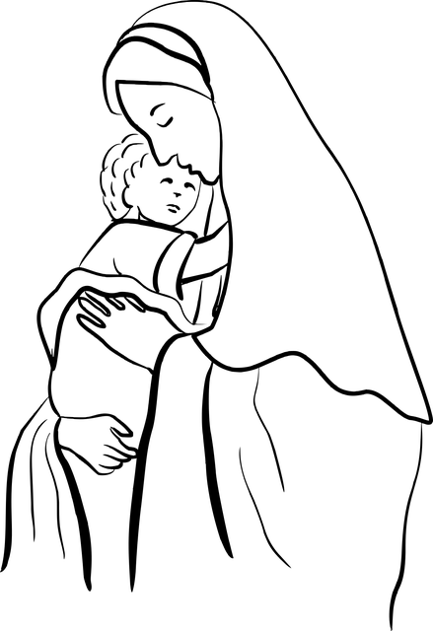

³⁸ Then Mary said,
“Here am I, the servant of the Lord; let it be with me according to your word.”
Then the angel departed from her.

Image by <a href="https://pixabay.com/users/jo-b-246441/?utm_source=link-attribution&amp;utm_medium=referral&amp;utm_campaign=image&amp;utm_content=2831182">Jo-B</a> from <a href="https://pixabay.com/?utm_source=link-attribution&amp;utm_medium=referral&amp;utm_campaign=image&amp;utm_content=2831182">Pixabay</a>

Yr B Advent Sunday Readings
 | 1st reading | Psalm | 2nd reading | Gospel Acclamation | Gospel
1st Sunday of Advent - B | Isa 63:16b-17, 19b; 64:2-7 | Ps 80:2-3, 15-16, 18-19 | 1 Cor 1:3-9 | Ps 85:8 | Mark 13:33-37
2nd Sunday of Advent - B | Isa 40:1-5, 9-11 | Ps 85:9ab+10, 11-12, 13-14 | 2 Pet 3:8-14 | Luke 3:4+6 | Mark 1:1-8
3rd Sunday of Advent - B | Isa 61:1-2a, 10-11 | Luke 1:46-48, 49-50, 53-54 | 1 Thess 5:16-24 | Isa 61:1 (cited in Lk 4:18) | John 1:6-8, 19-28
4th Sunday of Advent - B | 2 Sam 7:1-5, 8b-12, 14a, 16 (diff) | Ps 89:2-3, 4-5, 27+29 | Rom 16:25-27 | Luke 1:38 | Luke 1:26-38

https://catholic-resources.org/Lectionary/1998USL-Advent.htm
Each of the four Sundays of Advent has its own special readings and characteristics:

- First Sunday of Advent - The readings look forward to the “End Times” and the coming of the “Day of the Lord” or the “Messianic Age;” the Gospel is an excerpt from the Apocalyptic Discourse of Jesus in one of the Synoptic Gospels.
- Second Sunday of Advent - The Gospel readings focus on the preaching and ministry of John the Baptist as the forerunner of Jesus, the one who came to “Prepare the Way of the Lord.”
- Third Sunday of Advent - The Gospel readings continue to focus on John the Baptist, while the first and second readings convey the joy that Christians feel with the increasing closeness of the incarnation and the world's salvation.
- Fourth Sunday of Advent - The Gospels tell of the events that immediately preceded the birth of Jesus, including the dreams and visions of Joseph and Mary of Nazareth.

